Using Googledocs:
- You need a Gmail account.
- Open your Gmail account. Click on the “document” tab (see below).
- Click on “create new”. Choose whether you want a document, presentation, spreadsheet etc..
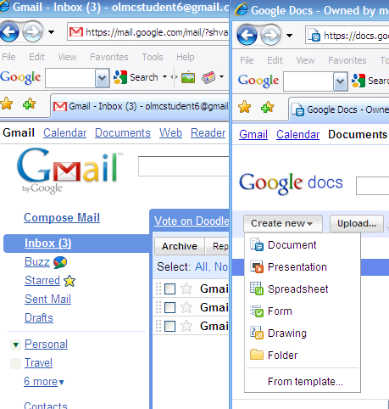
3. Choose one.
2.
1.
- Work on the document. Remember to save it. You can now open it from any computer that is connected to the internet by logging on to the internet.
- To allow your students to edit the document you need to share it. Click on the “share” button. There are now new options for sharing Google docs.
- For greater privacy you may choose to only share the document with users whose Gmail addresses you provide. Only your students can see and edit the document but this is time consuming to set up and all your students need a Gmail account.
- For collaborative work an easier option is to use the “anyone with the link” option. Gmail will provide a link to the document which you can either e-mail to your students or link to Moodle or similar. Tick “allow anyone to edit (no sign-in required)” (see below).
